|  |  |
| --- | --- |
|  | SOFTWARE DEFINED NETWORKING  Xem thông tin trên mạng SDN |

Nhóm học phần:

1) Mã SV, Họ và tên

2)

3)

MỤC LỤC

1. Example: mininet02a.py 1

2. Example: mininet02b.py 2

3. Example topo3s4h.py 3

4. Example: mininet_remote_controller.py 4

5. Example xyuanlab4.py 6

6. References 8

*>> Yêu cầu chụp hình ảnh là kết quả thực hành của SV. Không sử dụng lại hình ảnh của bài lab.*

# Access to nodes in the SDN network

The following command will launch mininet creating a small network of 4 hosts and 1 switch, and connect the switch to the Floodlight controller using OpenFlow version 1.3:

sudo mn --controller=remote,ip=127.0.0.1,port=6653 --switch ovsk,protocols=OpenFlow13 --topo single,3

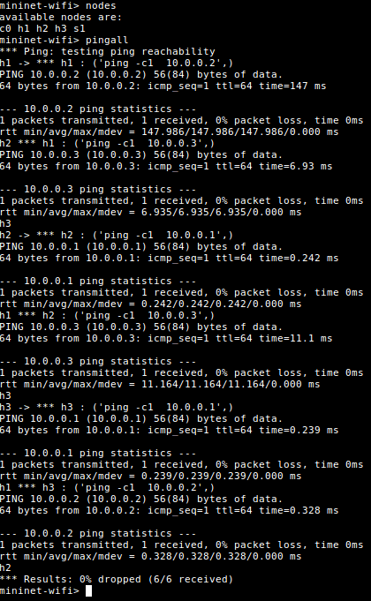

Commands can be executed on individual nodes using the following sequence ‘ ’, for example ‘h1 ifconfig’ would execute the ‘ifconfig’ command on node ‘h1’. Moreover, hosts can be instructed to ping each other using this command method. Issuing the command ‘h1 ping h2’ on the Mininet CLI will cause ‘h1’ to ping ‘h2’.

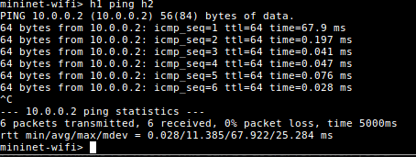

The ‘xterm’ command can be used to open individual terminals for hosts. This can be useful for when you’d like to run a program from one host and view results or impact from another hosts.

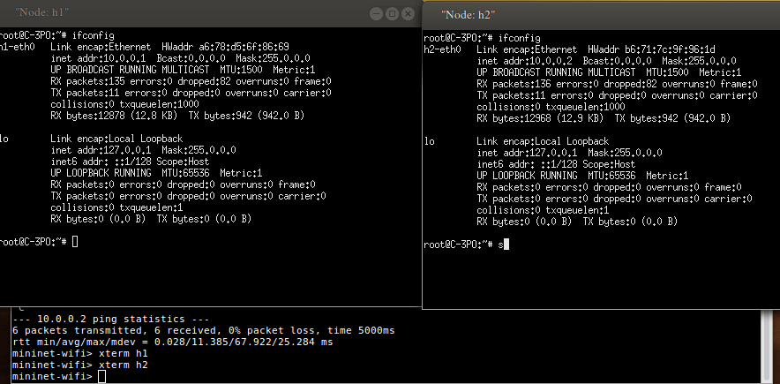

You can also try and send different type of packets between the hosts. Iperf can be used to achieve this.

# Using Iperf to send UDP and TCP packets

In the Mininet CLI, open terminal windows for h1 and h2 using:

xterm h1

xterm h2

In the Xterm window of h1:

iperf -s -u

Here -u specified the type of packets to be UDP.

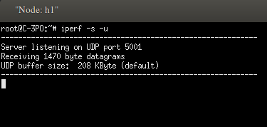

In the Xterm window of h2:

iperf -c 10.0.0.1 -u

10.0.0.1 is the IP address of the server host(which is h1 in this case.)

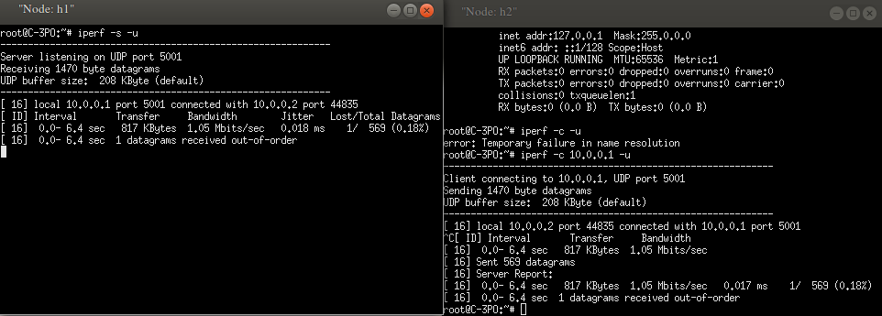

**b) Interacting with Switches**

The switches used in the Mininet network are OpenVSwitch switches and rely on the ovs-ofctl tool for interaction. Open a separate terminal window using the ‘xterm s1’ command to interact with switch s1.

In s1’s terminal window, issuing the command the ‘dump-flows’ will print the flows currently installed in the switch and the ‘dump-tables’ command will print all the flow tables.

ovs-ofctl dump-flows s1 -O OpenFlow13  
ovs-ofctl dump-tables s1 -O OpenFlow13

Once you learn to write rules, you can set up some rules of your own and come back here to check if the flow rules have been properly installed in the switch.

Also,the snoop command can be actually used to see all incoming and outgoing traffic at s1.

ovs-ofctl snoop s1

# References

1. https://medium.com/@click4abhishekagarwal/getting-started-with-sdn-597663e5caef

(Tài liệu lưu hành nội bộ)

-----------------------------------------------